Exercise 04

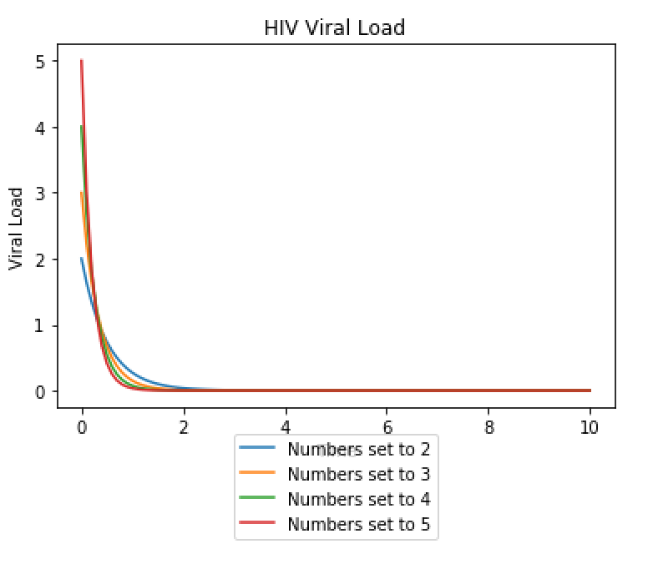

The plot above shows how the graphs look differently when both alpha and A are set to different numbers. In this case I set alpha and A to the same number in each situation and varied what that number was for each plot. As alpha and A are increased the steepness of the slope increases.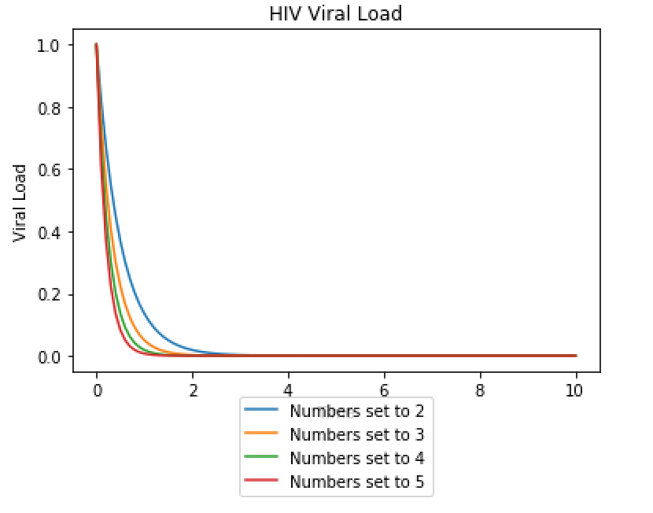

The above plot is what happens when A is held constant at 1 while alpha is set to 2-5. This means the starting point is consistently at 1 and the steepness of the curve changes with alpha.

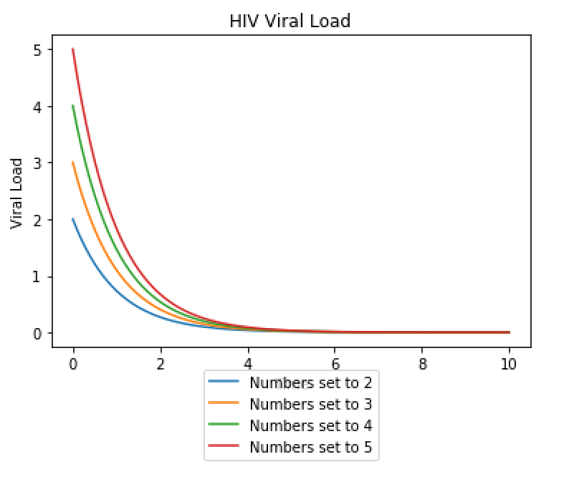

In this plot alpha is held constant at 1 while A is set to between 2 and 5. The starting points vary with A but the lines all converge on one point.